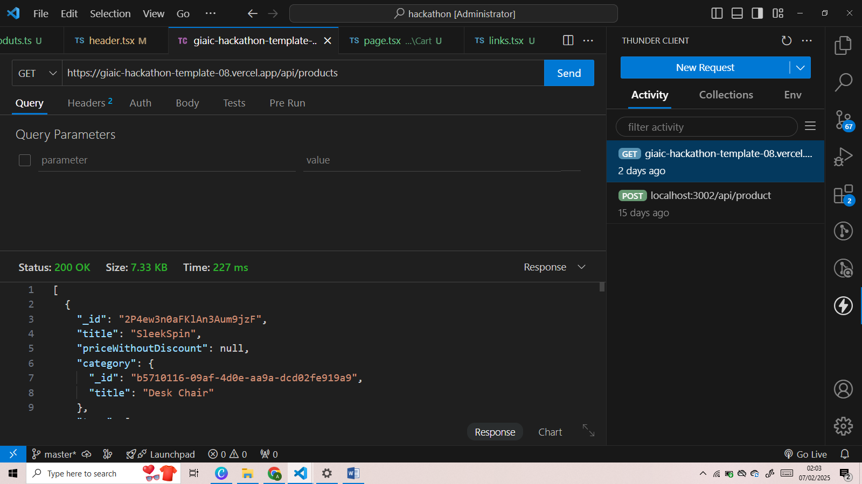

Backend API Testing

API successfully working:

Dynamic Routes

All products are dynamically worked with their specific id: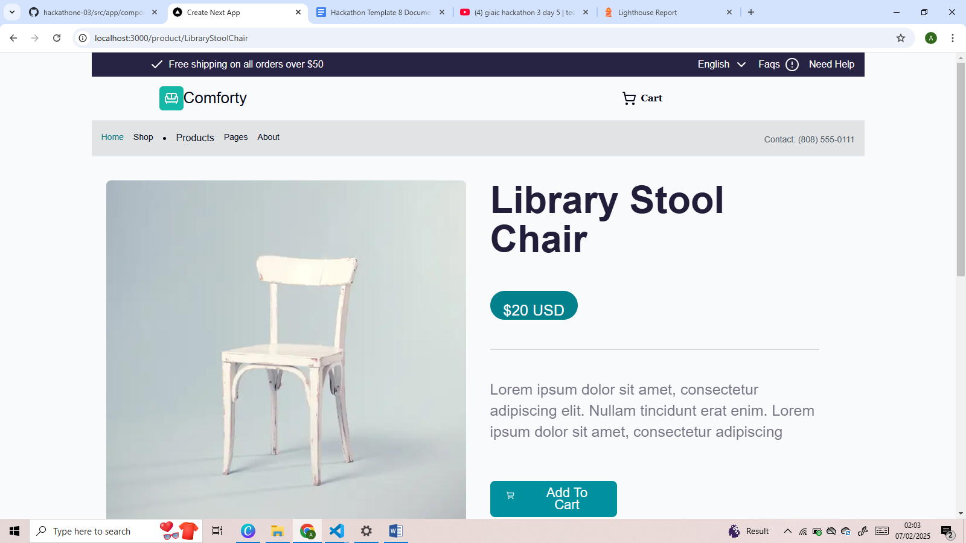

Clear Cart functionality:

All the products will be cleared with one button “Clear Cart”

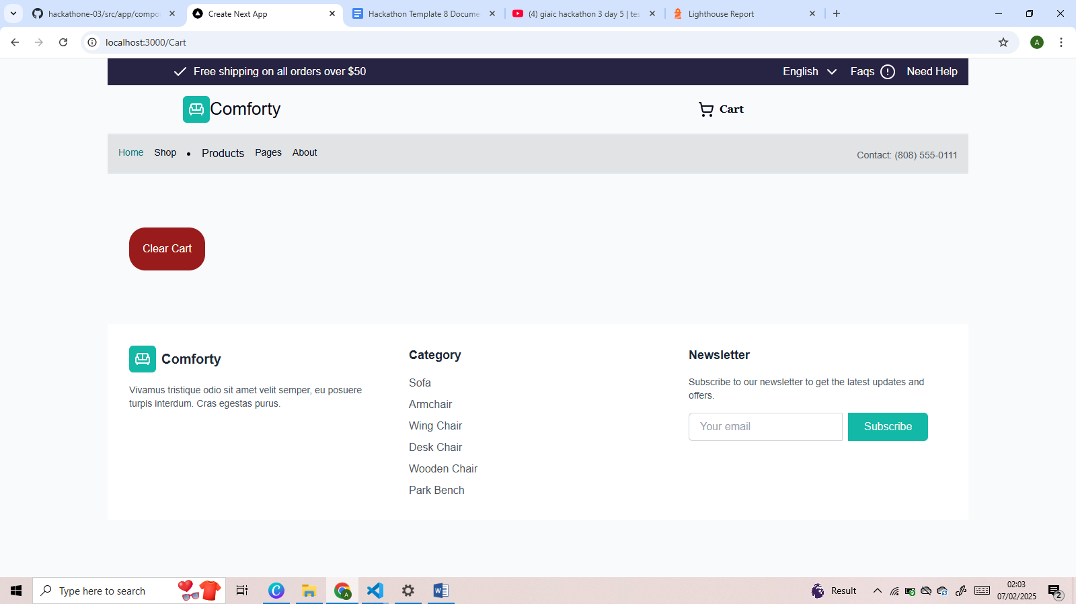

LightHouse:

Using of lighthouse to review the performance and accessibility issues

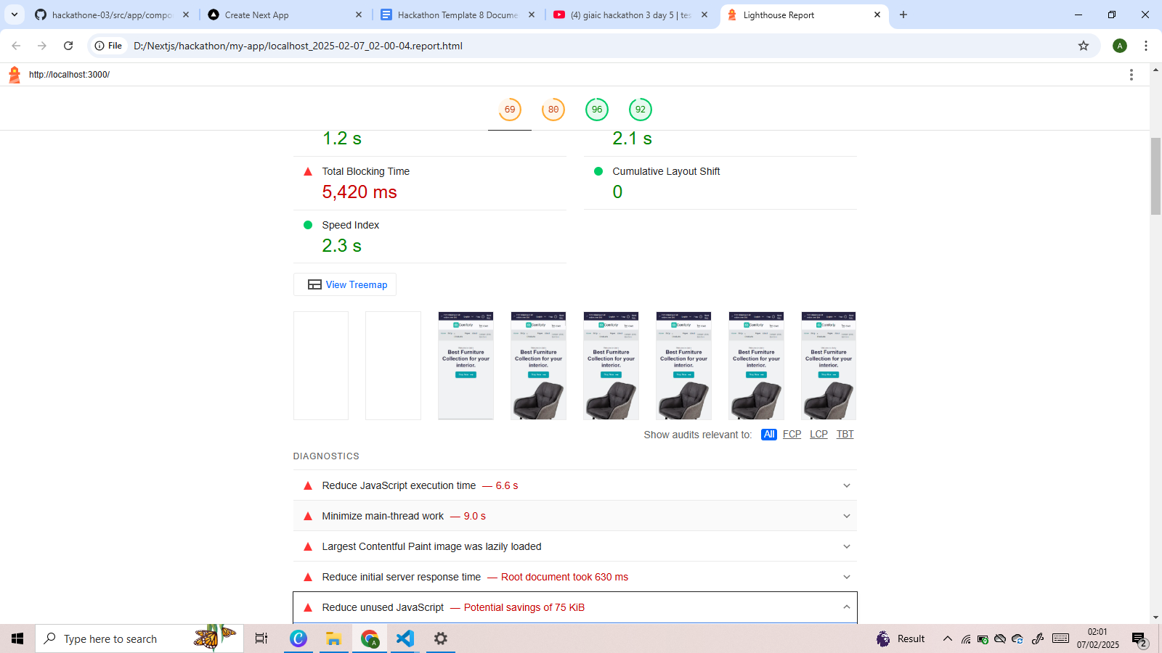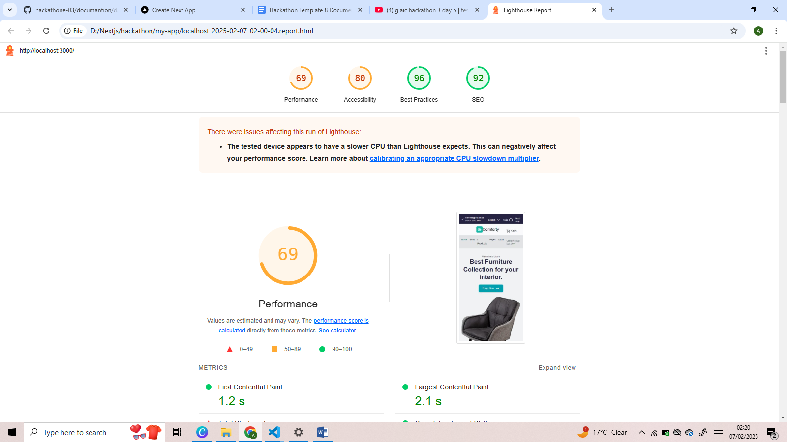

Products-listing:

All products have been listen in the fornt-page.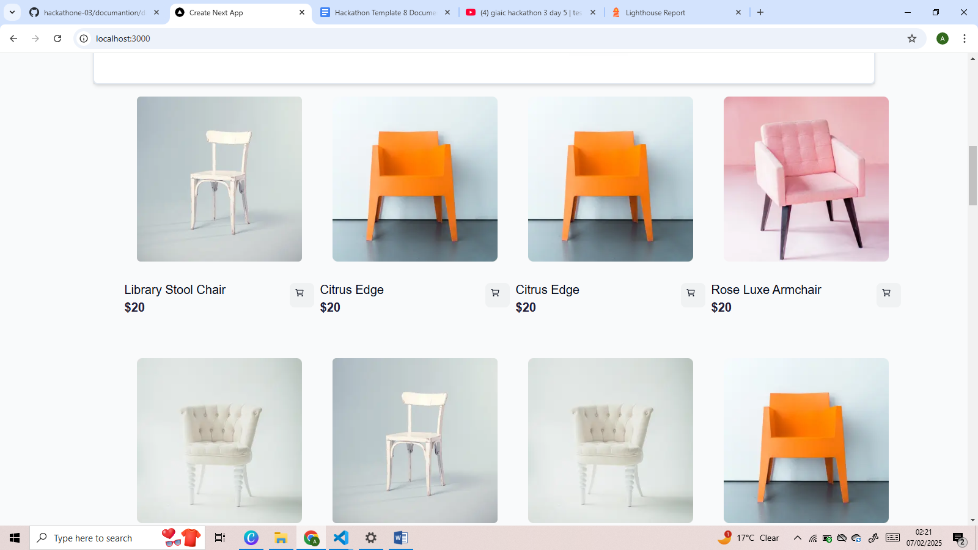

Featured Products Function:

After cart some products are shown as a featured products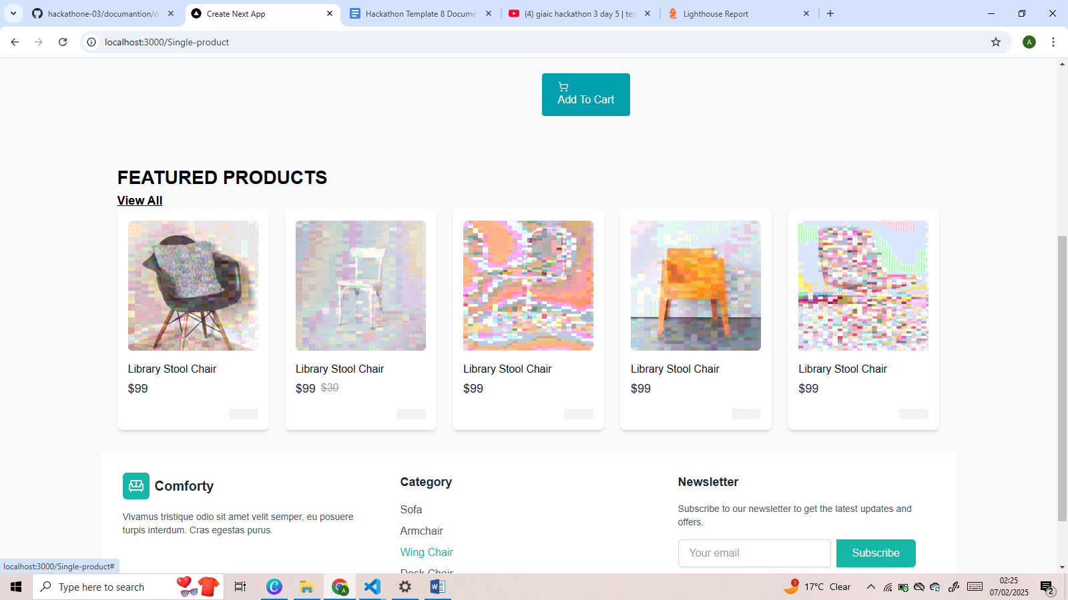

Add to Cart functionality: